**BUMANGLAG, ANGELINE D. BSCS – C203**

**Midterm Task 5**

**Creating Class and Instantiating Objects in Python**

1. CONSTRUCTOR

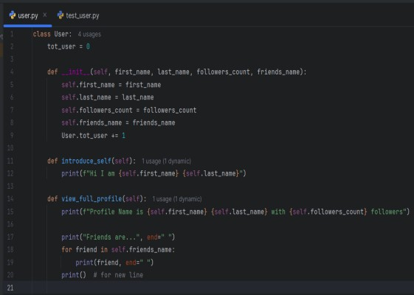

1. TEST USER CLASS

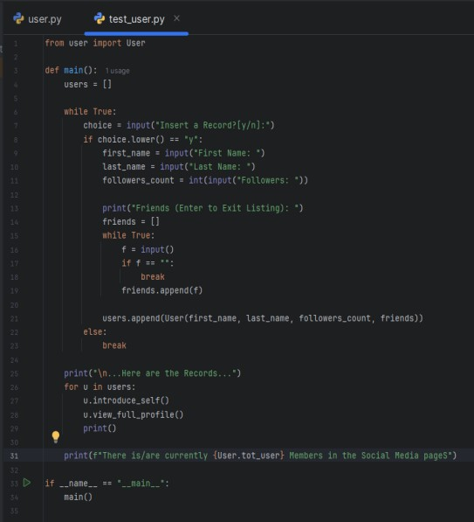

1. OUTPUTS

